

COMP9900 Project Report of Myrecipes

GROUP – COMP9900-H13A-aBOUTtOGRADUATE

Submission Date:

2nd August 2021

Team Member:

**Yunfan Wang** Scrum Master Z5171928 Z5171928@ad.unsw.edu.au

**Qinyu Chen** Developer Z5242233 Z5242233@ad.unsw.edu.au

**Xiaocong Chen** Developer Z5282006 Z5282006@ad.unsw.edu.au

**Zhiyu Gu** Developer Z5240598 [Z5240598@ad.unsw.edu.au](mailto:Z5240598@ad.unsw.edu.au)

**Zihan Yu** Developer Z5242308 Z5242233@ad.unsw.edu.au

**Zihan Yu** Developer Z5242308 Z5242308@ad.unsw.edu.au

Contents

1. Overview 1

1.1 Software Design and Architecture 1

1.1.1 Data Tier 1

1.1.2 Application Tier 1

1.1.3 Presentation Tier 2

2. Functionalities and How They Map Project Objectives 3

2.1 Login/Signup 4

2.2 Profile and recipe management 5

2.3 News feed and subscribe 7

2.4 Search 7

2.5 Details of recipe, like, subscribe and comment 8

3. Third-Party Functionalities 10

3.1 Front End 10

3.1.1 Bootstrap 10

3.1.2 Wordcloud2 10

3.1.3 CodyHouse.co 11

3.2 Back End 11

3.2.1 Flask 11

3.2.2 SQLAlchemy 12

3.2.3 Flask-migrate 12

3.2.4 OpenCV 12

4. Implementation Challenges 13

4.1 Front End 13

4.1.1 Consistent like number 13

4.2 Back End 13

4.2.2 Recommendation Systems 14

5. User Document/Manual 15

5.1 Build, setup and configure 15

5.1.1 System building and setup 15

5.1.2 Running System 16

5.2 system and functionalities 16

5.2.1 User authentication 16

5.2.2 Public Exploration 20

5.2.3 Profile 21

5.2.4 Recipe 23

5.2.5 Search 25

5.2.6 Interaction 29

5.2.7 Personalization 32

6. Reference 36

# Overview

## 1.1 Software Design and Architecture

### 1.1.1 Data Tier

The data tier consists of 2 parts. The first part is text data, which includes user information, recipe detail, comments that an explorer post under a recipe, etc. We choose SQLite as our database to manage these text data. Besides, all images including user avatars and recipe pictures will be stored separately in a specific file to reduce the I/O request in the database.

SQLite has several merits in the project. Firstly, it is a lightweight database management system with reliable performance when HTTP traffic is low to medium. As this is a no-installation database, it can be portable through different development environment and shared by teammates easily. Although it cannot handle large data, we choose to use SQL Alchemy to initialize and interact with database in our application tier so that the database can be changed without ang significant upgrades for our project.

### 1.1.2 Application Tier

Application tier is the middle tier to build a connection between data tier and presentation tier. We choose flask and its extended libraries, such as flask migrate and flask SQLalchemy, for this layer. They can build and manipulate different kinds of database from Python command, so it can decrease the cost of database change and is adept at managing database. Besides flask can set up a RESTful API with plenty of support libraries and transform messages between back end and front end safely and conveniently.

### 1.1.3 Presentation Tier

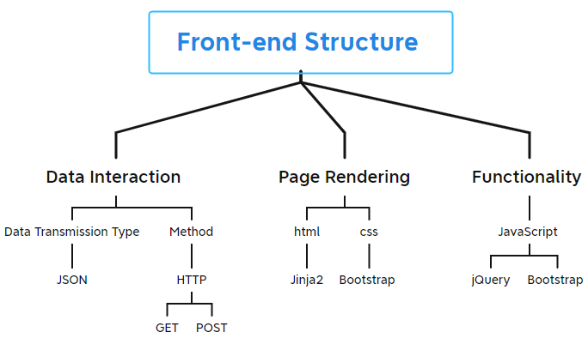

Figure 1.1.1 Front End Structure

Jinja is a fast, expressive, extensible templating engine. Bootstrap is a [CSS framework](https://en.wikipedia.org/wiki/CSS_framework) that contains [CSS](https://en.wikipedia.org/wiki/CSS) and [JavaScript](https://en.wikipedia.org/wiki/JavaScript) templates. Each web page has its own .html file. Its constant layout and style will be rendered at back-end side by Jinja then return to browser. Then, using ajax (retrieve data from a [server](https://en.wikipedia.org/wiki/Web_server) asynchronously) to get dynamic data then render corresponding’s layout and style. When client post a GET request, the back-end server will response JSON data. POST request is used to submit forms like new recipe form, sign in form, sign up form and search form.

# Functionalities and How They Map Project Objectives

|  |  |  |
| --- | --- | --- |
| Number | Functionalities | Project objectives |
| 1 | describe in 2.2 | Contributors must be able to create and maintain a profile for themselves, which includes their username, contact details (email address), and a list of recipes that this contributor has published, and to which MyRecipes users can navigate to. |
| 2 | describe in 2.2 | The MyRecipes platform must allow contributors to maintain a set of their own recipes, (create/edit/delete recipes), that all platform explorers can look through, with each recipe requiring a name, ingredients, method, meal-type(s) and a photo. |
| 3 | describe in 2.2 and 2.5 | Recipe explorers on the platform must also be able to convey their opinion for any recipe by either liking and/or commenting on it. |
| 4 | describe in 2.4 | MyRecipes must also provide its explorers with the ability to find recipes they are interested in based on any combination of the following: ingredients, method, meal-type(s), recipe name; where a resulting list of entries should show a summary that includes the name, and photo thumbnail for each recipe that they can navigate to the details from. |
| 5 | describe in 2.4 and 2.5 | Explorers must be able to navigate to the full details of any given recipe they find, where these full details include: the recipe name, ingredients, method, meal type(s), a photo for the recipe, the number of likes for the recipe, and recipe comments. |
| 6 | describe in 2.3 | Explorers must also be able to subscribe/unsubscribe to any contributors on MyRecipes, and when an explorer is subscribed to a given contributor, that explorer should, (on their personal recipe news feed), be able to see new recipes that are added or have been recently updated by that contributor. |
| 7 | describe in 2.3 | A given explorer's personal recipe news feed must be sorted based on: the recipe creation/update date excluding time component (most recent to oldest), then by the total number of likes that this explorer has for the recipe's contributor profile (highest to lowest count), and then by the recipe creation/update time (most recent to oldest). |
| 8 | describe in 2.5 | MyRecipes must provide recommendations for recipes that are similar to a given reference recipe based on that reference recipe's ingredients, with recommendations to be ordered based on how close each result is to the reference recipe's ingredients |

Table 1 Project Objective Forms

## 2.1 Login/Signup

A user can explore ranking recipes in homepage and recipes by different meal types. When he/she wants to get more functionality, he/she can sign up/log in. Three shortcut links in the upper menu bar can be easy to access my profile, news page, my favorite list and create a new recipe.

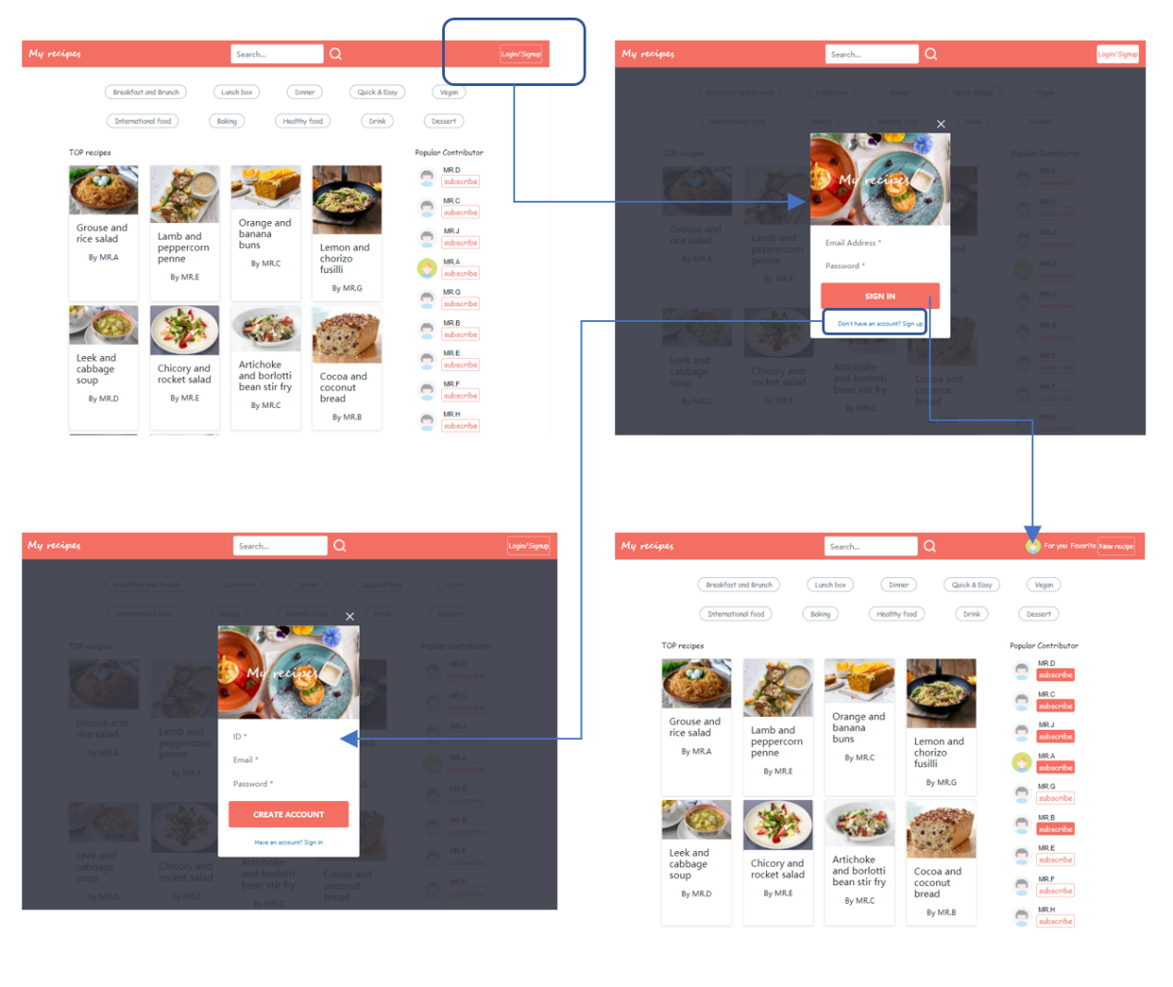

Figure 2.1.1 Login/Sign up Steps

## 2.2 Profile and recipe management

On the profile page, there is a menu bar which consists of four elements and a number represents the counts of likes by other users. A user can update his/her information in his/her profile. The posts subpage lists all the recipes uploaded by user and sets quick access to create/edit recipe page that can create, update, and delete recipes. The favorite subpage shows all the recipes that user liked. If he/she doesn’t like this recipe anymore, he/she can click like icon to cancel like. Favorite subpage shows all the contributors that user subscribed. If he/she wants to unsubscribe, he/she can click ‘unsubscribe’ button to unsubscribe.

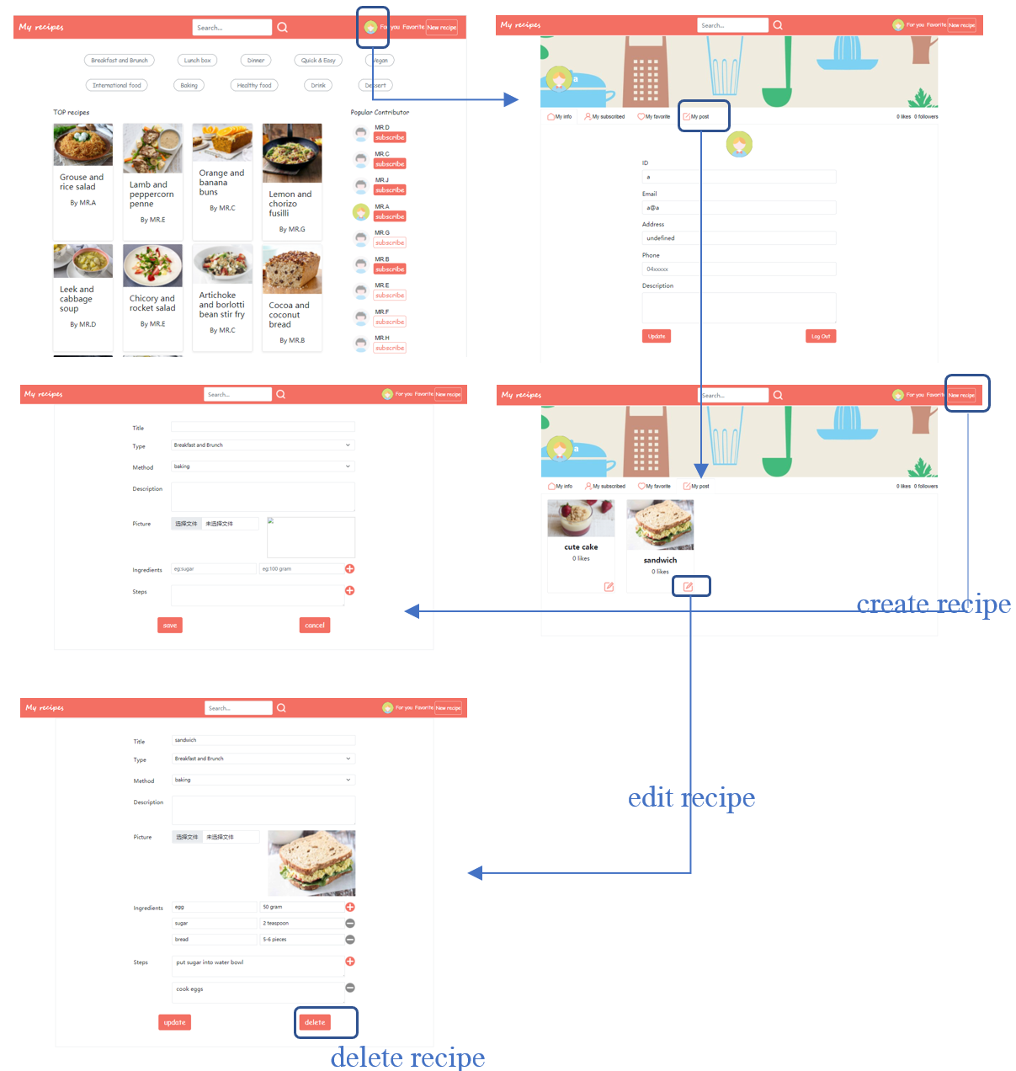

Figure 2.2.1 Recipe Manage Steps

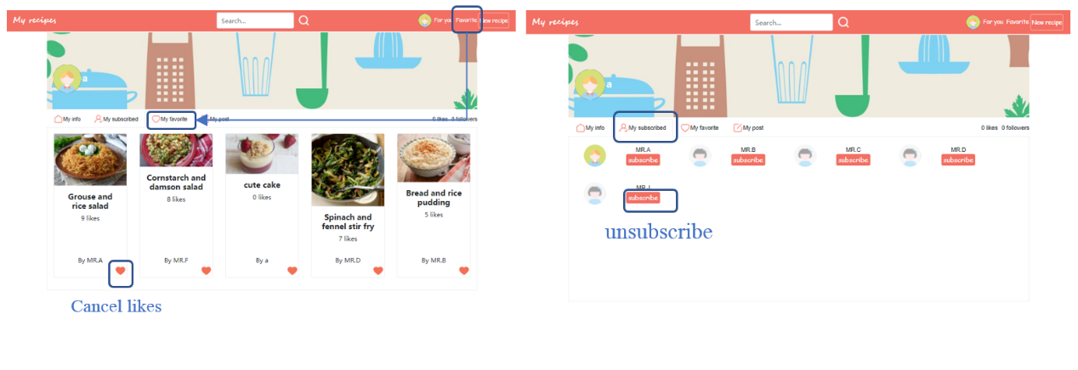

Figure 2.2.2 Interaction Function Management

## 2.3 News feed and subscribe

On this page, a user can check new posts posted by subscribed contributors.

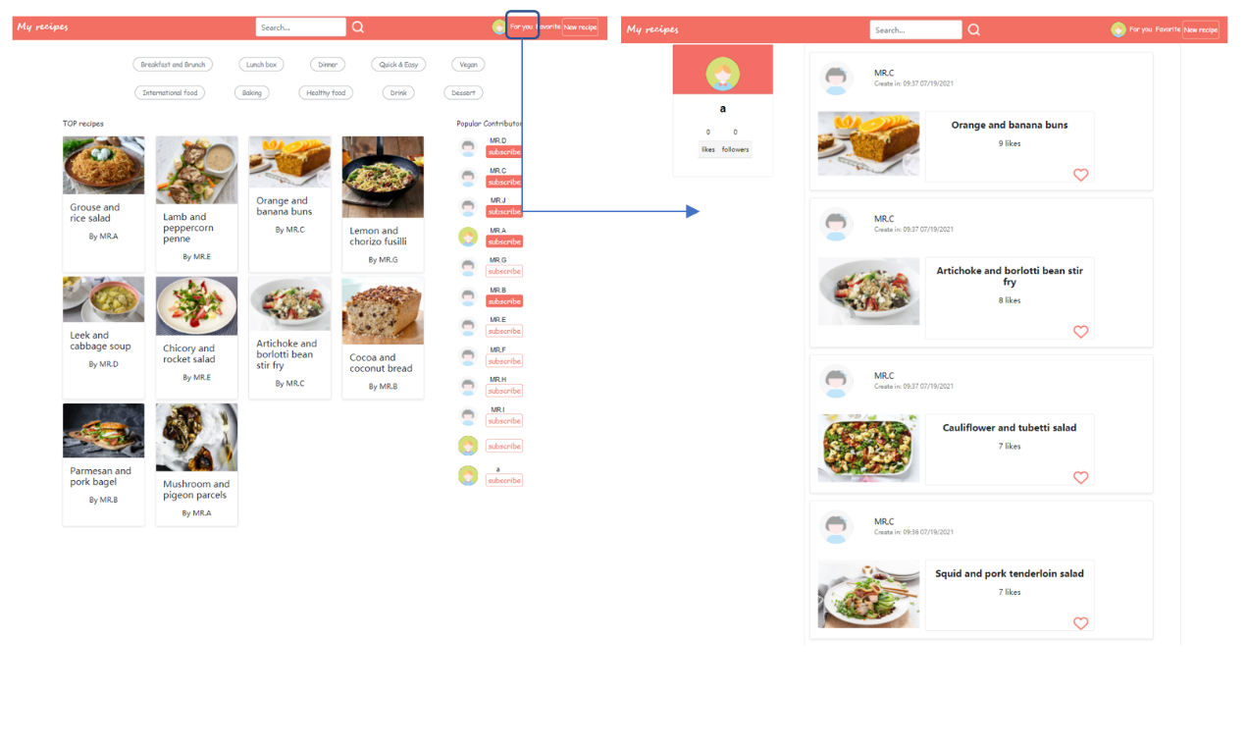

Figure 2.3.1 News Page

## 2.4 Search

The entry of search page is in the middle of upper menu bar. A user can find recipes they are interested in based on any combination of the following: ingredients, method, meal-type(s), recipe name. Click the title of a specific recipe, users are navigated to the detail page of that recipe.

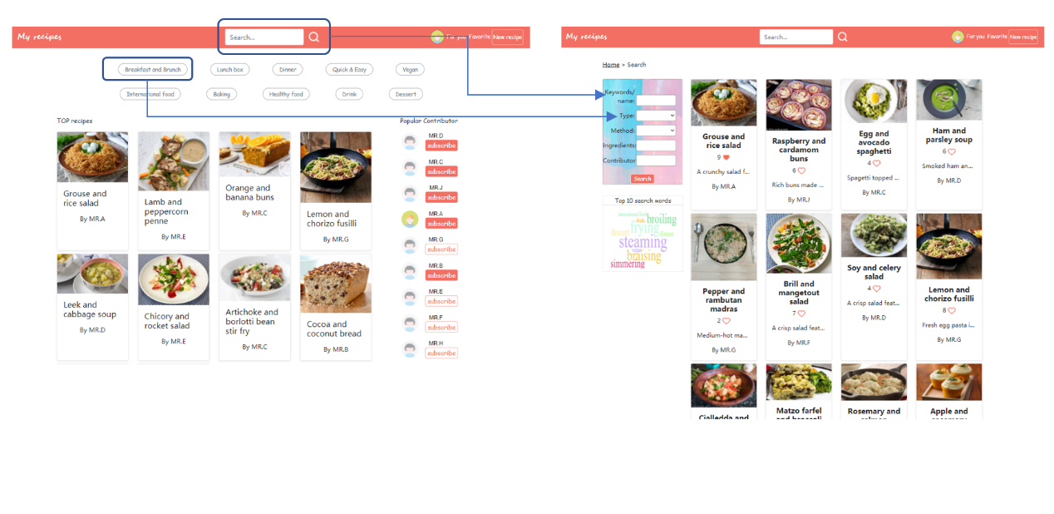

Figure 2.4.1 Search Page

## 2.5 Details of recipe, like, subscribe and comment

A user can post comments, subscribe contributors and like a recipe in the recipe page. Some recommendation related to current recipe are showed in the right panel.

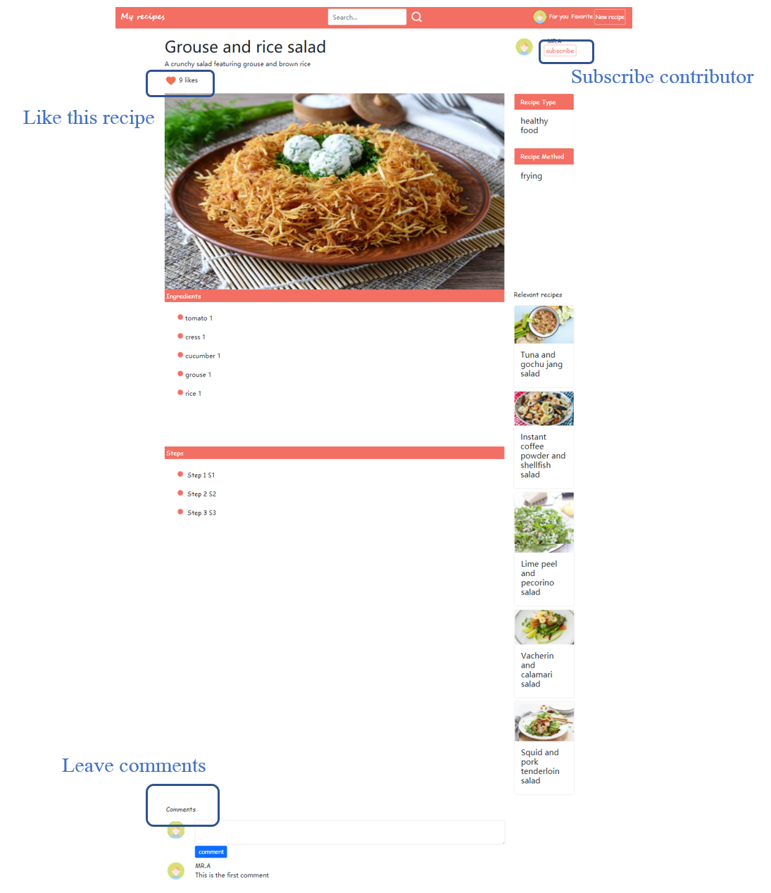

Figure 2.5.1 Recipe Detail Page

# Third-Party Functionalities

## Front End

### 3.1.1 Bootstrap

Bootstrap is one of the world’s most popular front-end open-source toolkits, featuring Sass variables and mixins, responsive grid system, extensive prebuilt components, and powerful JavaScript plugins.

We choose bootstrap mainly because it helps us quickly design and customize responsive websites. It provides Bootstrap’s compiled CSS and JS, icons, and official themes. In addition, it provides simple start template and examples, which help our group learn and use it easily.

It permits users to: freely download and use Bootstrap, in whole or in part, for personal, private, company internal, or commercial purposes. It also permits users to modify the source code and grant a sublicense to modify and distribute Bootstrap to third parties not included in the license. Therefore, we just need to keep the license and copyright notice included in Bootstrap’s CSS and JavaScript files when we use them in our project.

### 3.1.2 Wordcloud2

Wordcloud2 is probably one of the best word cloud JavaScript codes available today. It not only helps us to draw a word cloud graph in an easy way but also provides various options to customize the style of the graph.

We select Wordcloud2 because we want to show a word cloud graph on our recipe search page, allowing explorers to know about the top 10 search words and what the trends of recipes are.

In terms of license, it permits users to obtain a copy of Wordcloud2 and associated documentation files, to deal on the website without restriction, including without limitation the rights to use, copy, modify, merge, publish, distribute, sublicense, and/or sell copies of the website, and to permit persons to whom the website is furnished to do so. We should include the copyright notice and permission notice in all copies or substantial portions of our website.

### 3.1.3 CodyHouse.co

CodyHouse is a website providing a lightweight front-end framework for building accessible and bespoke interfaces, a collection of web design tools to create and export things like typography elements, color themes, spacing rules, buttons and forms, and a library of 357 accessible, progressively enhanced, HTML, CSS, JS components that work seamlessly with its framework.

We choose to use a login component from CodyHouse website because that component can be modified to be consistent with our design. UI design of this component is excellent, through which we can make our website more concise and aesthetically pleasing.

In terms of license, for the component part, users are allowed to build a website or a Wordpress theme for a client. Users can also use it to build the interface of a project/product that anyone can download for sale of for free. Therefore, we can use and modify the login component in our project if we do not distribute them or a ‘pluginized’ version of them for sale or for free.

## 3.2 Back End

### 3.2.1 Flask

Flask is a lightweight web application framework written in Python. Its WSGI toolbox uses ‘Werkzeug’, and its template engine uses ‘Jinja2’. Flask uses BSD authorization. Flask is also called "microframework" because it uses a simple core and uses extensions to add other functions. Flask does not have a default database or form verification tool.

We select Flask to be our main tool, mainly because it is more flexible, lighter, safer and easier to use than other frameworks of the same type. It can also be developed well in combination with the MVC model. As a small team, we can make our feature-rich and medium-sized websites in a few months. In addition, Flask is also highly customizable. We are able to add some corresponding functions according to our own needs. While keeping the core functions simple, we can also realize the enrichment and expansion of our functions by using Flask.

### 3.2.2 SQLAlchemy

SQLAlchemy is an open-source software under the Python programming language. It provides SQL toolkit and object-relational mapping (ORM) tools, issued under the MIT license.

Since we select Python to develop our webpage, SQLAlchemy is a good choice for establishing the database. This toolkit has built a bridge between relational databases and traditional programming, helping Python programmers to connect applications to relational databases.

### 3.2.3 Flask-migrate

Flask-Migrate is an extension that handles SQLAlchemy database migration for Flask applications, making it possible to operate the database through Flask's command line interface or Flask-Scripts. We use this toolkit for the interaction between Flask and database.

### 3.2.4 OpenCV

OpenCV is a cross-platform computer vision and machine learning software library released under the BSD license (open source). We use this toolkit for loading and saving pictures of users and their recipes.

# Implementation Challenges

## Front End

### 4.1.1 Consistent like number

#### 4.1.1.1 Problem Statement

In our design, on the search page, users can like and cancel like of a specific recipe. After clicking the title of that recipe, they are navigated to the detail page where they can also like and cancel like of that specific recipe. However, the state and number of likes displayed at these two pages are sometimes not the same.

#### 4.1.1.2 Solution

At first, we find that the wrong number of likes is caused by the wrong state displayed at the page. We check our codes and change the condition of transferring like state. It improves a little, but the inconsistence still appears sometimes. After trying various methods, we finally found that the problem is caused because we have not refreshed the previous page in time. Therefore, we add an exact part of code to refresh pages automatically when the return button is pressed.

### 4.2 Back End

#### 4.2.1.1 Problem Statement

Although Flask has a secret key to enhance the system safety, the database is still lack of authentication or validation measures to keep users’ data safe.

#### 4.2.1.2 Solution

Since it is difficult to build a strong database to protect data, we choose two alternative methods to reduce the risk of data leak. Firstly, we will hash users’ code in our database to improve the account security. Besides, we will have a cloud backup to prevent some destructive attacks.

### 4.2.2 Recommendation Systems

#### 4.2.2.1 Problem Statement

We want to make recommendations from multiple dimensions rather than simply based on the number of likes of recipes

#### 4.2.2.2 Solution

We have different recommendation methods distributed in our websites. In the index page, we will have our recipes recommended based on the number of likes and also have recommended popular contributors. Besides, in the search page, we introduce to explorers with hot food types and cook methods. This recommendation is required us to have a history log of scan habits, then we can generate it based on their customs.

# User Document/Manual

## 5.1 Build, setup and configure

* The system will be run under UNSW VLAB environment.
* Please use Google Explorer to run the system

### 5.1.1 System building and setup

* Firstly, create a directory for the project and change direct to it

$ mkdir <target directory>

$ cd <target directory>

* Secondly, download zipped file to <target directory> and upzip it

$ unzip <filename>

* Thirdly, setup the environment and all the packages should be installed. The command lines are shown below.

$ python3 -m venv venv

$ source venv/bin/activate

$ pip install Flask

$ pip install flask_migrate

$ pip install flask_login

$ pip install flask_wtf

$ pip install email-validator

$ pip install --upgrade setuptools

$ pip3 install --upgrade pip

$ pip install opencv-python

* Now you can find all the package are installed and the system is ready to run.

### 5.1.2 Running System

* Firstly, change the current directory to target directory

$ cd <target directory>

* Next, run export command under the directory to start the server

$ source venv/bin/activate

$ flask run

* Now you can find the system is running. Open the Google Explorer and go to 127.0.0.1/5000 to open the homepage.

## 5.2 system and functionalities

### 5.2.1 User authentication

General users can enjoy some services such as top recipe and contributor recommendation and search function without logging in, however, if they want to gain more personalized services like maintaining a profile, sharing opinions, and having personalized news feed, they should sign up and sign in their accounts.

When a user does not log in, the index page will show a navigation bar with a log in/ sign up button (Figure 5.2.1.1).



Figure 5.2.1.1 Unauthorized Navigation Bar

When a user logs in, the index page will show the user bar which contains his/her avatar and some quick accesses to personalized services (Figure 5.2.1.2).



Figure 5.2.1.2 Authorized Navigation Bar

#### 5.2.1.1 Sign up

A new user can sign up a new account by clicking the log in/ sign up button at the top right corner on the page (Figure 5.2.1.1), then a sign in pop-up box will appear in the center of the page (Figure 5.2.1.3). Choose the blue link ‘Don’t have an account? Sign up’ at the bottom of it, then the sign-up pop-up box will appear (Figure 5.2.1.4).

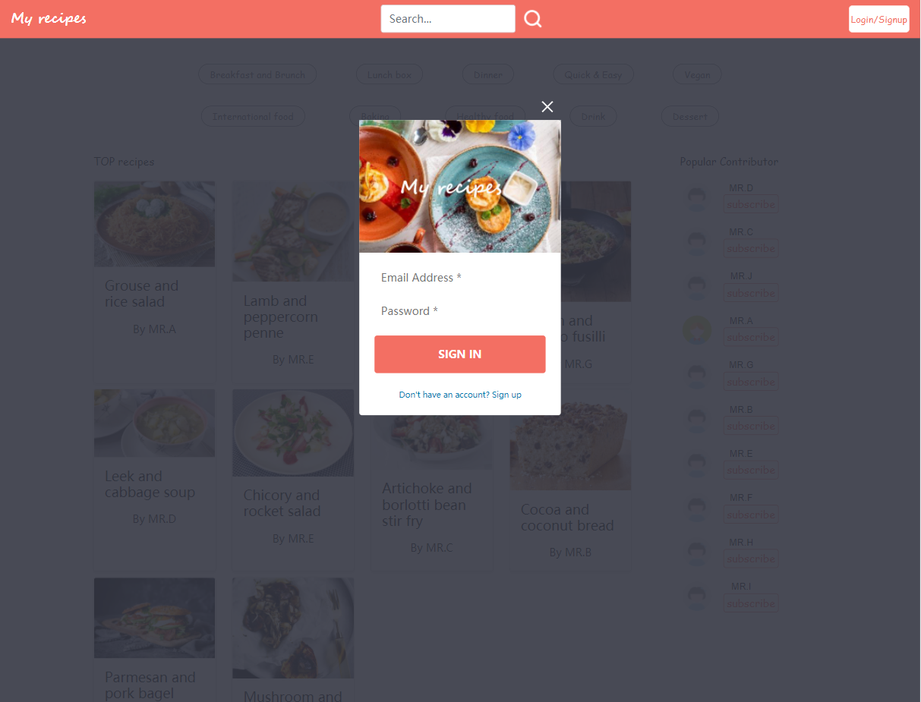Figure 5.2.1.3 Login Box

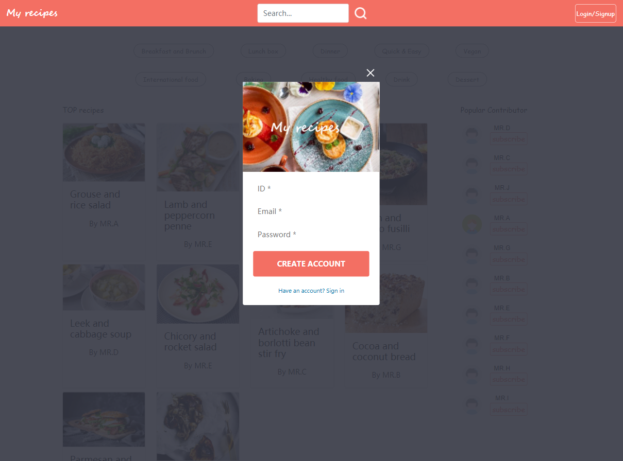

Figure 5.2.1.4 Sign-up Box

The user can sign up simply by providing ID, email, and password. After clicking the CREATE ACCOUNT button, a reminder showing whether the register procedure succeed or not will show up (Figure 5.2.1.5 and Figure 5.2.1.6). Then after three seconds, users are automatically navigated back to the index page.

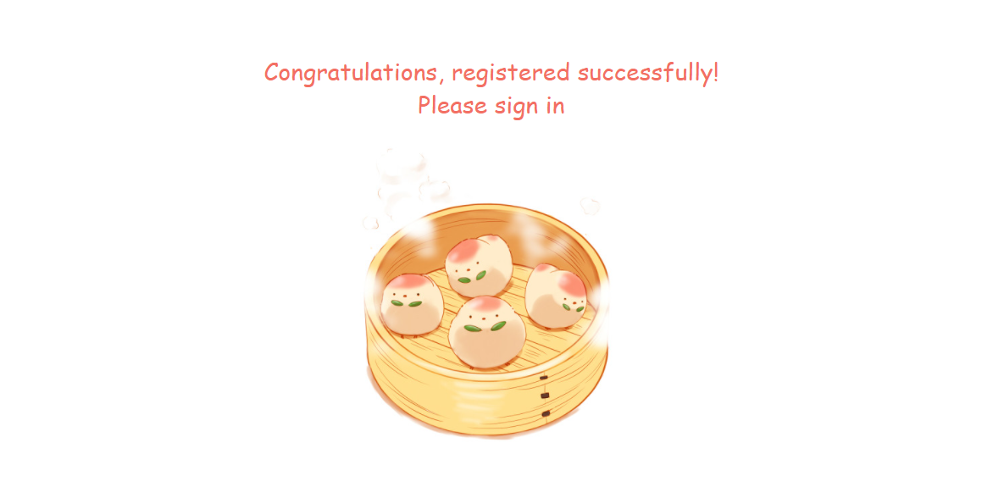

Figure 5.2.1.5 Register Succeed Feedback

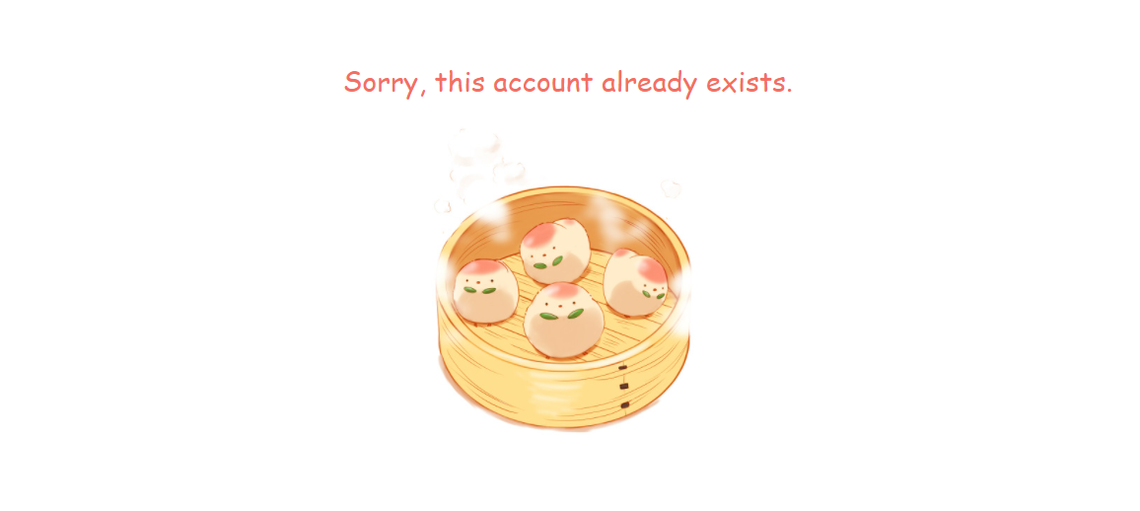

Figure 5.2.1.6 Account Exist Feedback

#### 5.2.1.2 Sign in

As for registered users, they can sign in the account by simply providing their email and password (Figure 5.2.1.3). If log in procedure fails, a reminder will show up to remind users to enter their log in information again (Figure 5.2.1.7). Otherwise, the user state will turn to true, and the user bar show up (Figure 5.2.1.2).

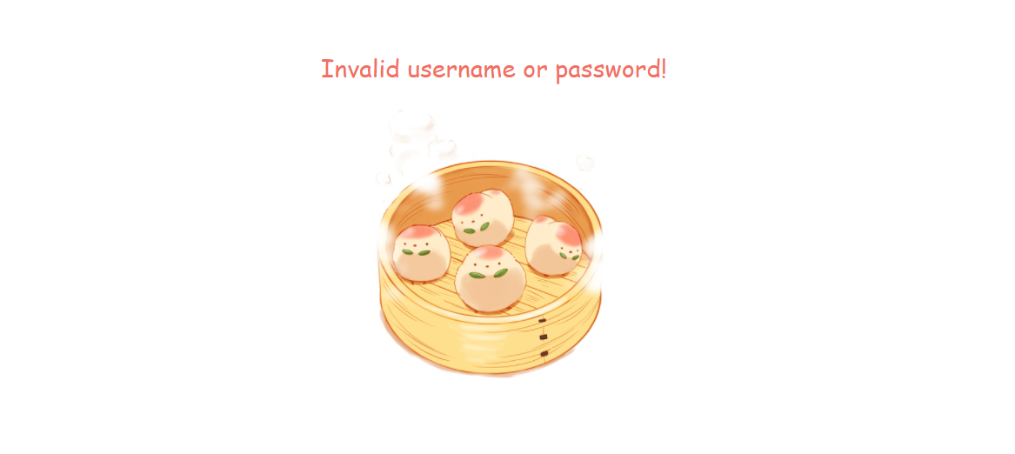

Figure 5.2.1.7 Invalid Login Feedback

#### 5.2.1.3 Sign out

To ensure the security of user accounts, a sign out function is added to our website. As this function is considered as a part of an account management, it can be easily found in the personal profile page. Clicking the user avatar on the top right corner of the current page to go to the profile page, users can see a log out button at the bottom right position (Figure 5.2.1.8). Users can press this log out button to log out their account.

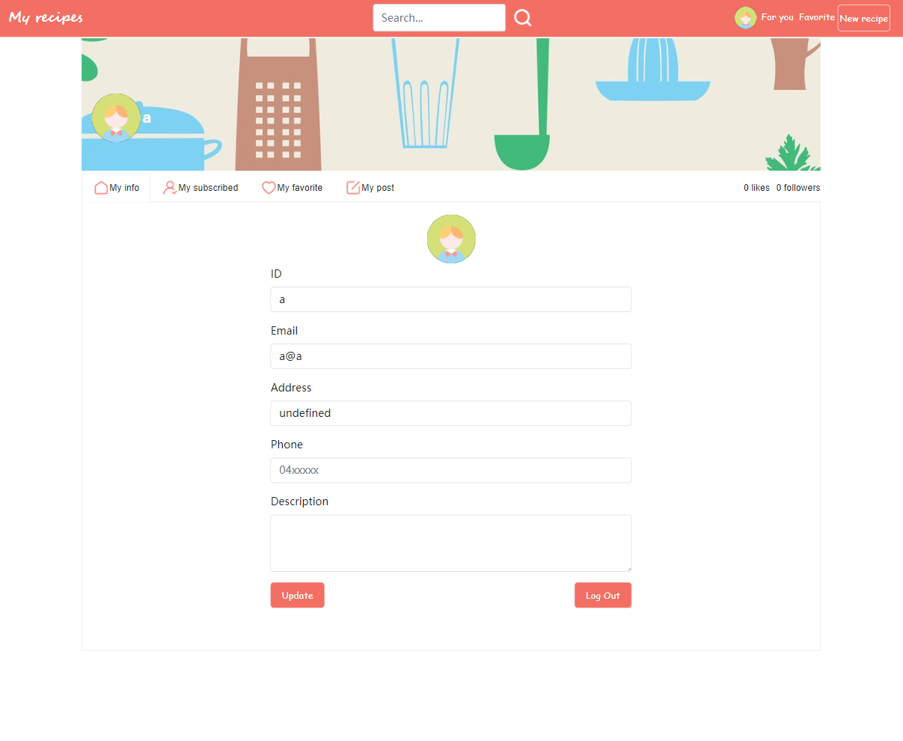

Figure 5.2.1.8 Sign out Page

### 5.2.2 Public Exploration

In homepage, there is a ranking list of top 10 recipes. The more likes that recipe received, the more popular this recipe is. Same as top ranking recipe list, contributor list shows the most popular contributor by ranking the total counting likes of contributor’s shared recipes (Figure 5.2.2.1).

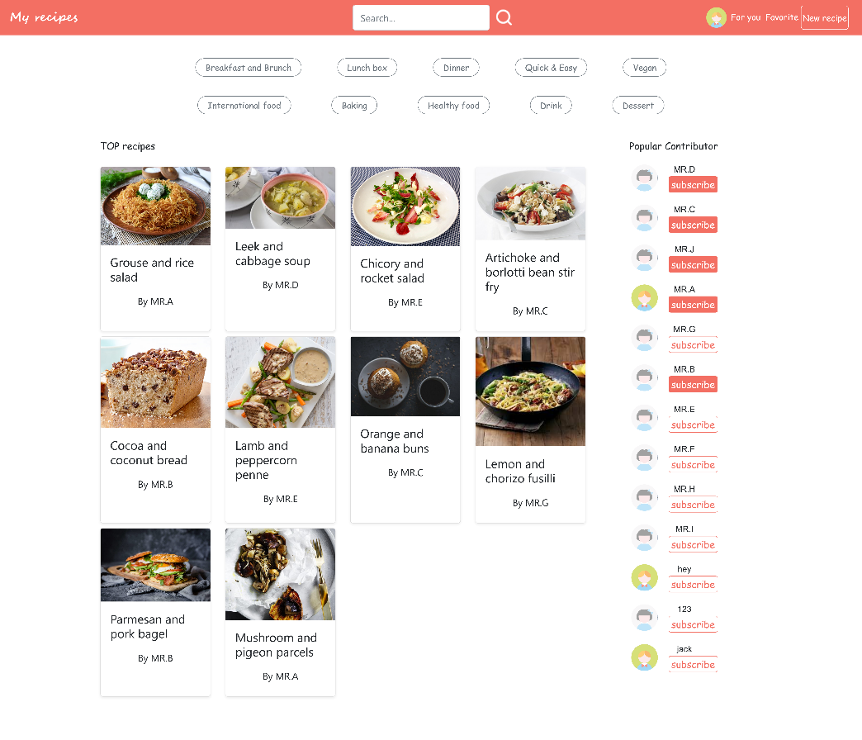

Figure 5.2.2.1 Index Page

### 5.2.3 Profile

#### 5.2.3.1 Create Profile

After the user successfully registers, the system will automatically create a default profile for him/her. By clicking the picture on the right top of the navigation bar, our user can easily jump to the profile page (Figure 5.2.3.1). The information stored in default profile page is contributed by the type-in ID, Email when user register his/her account. The other information of the profile remains empty and undefined.

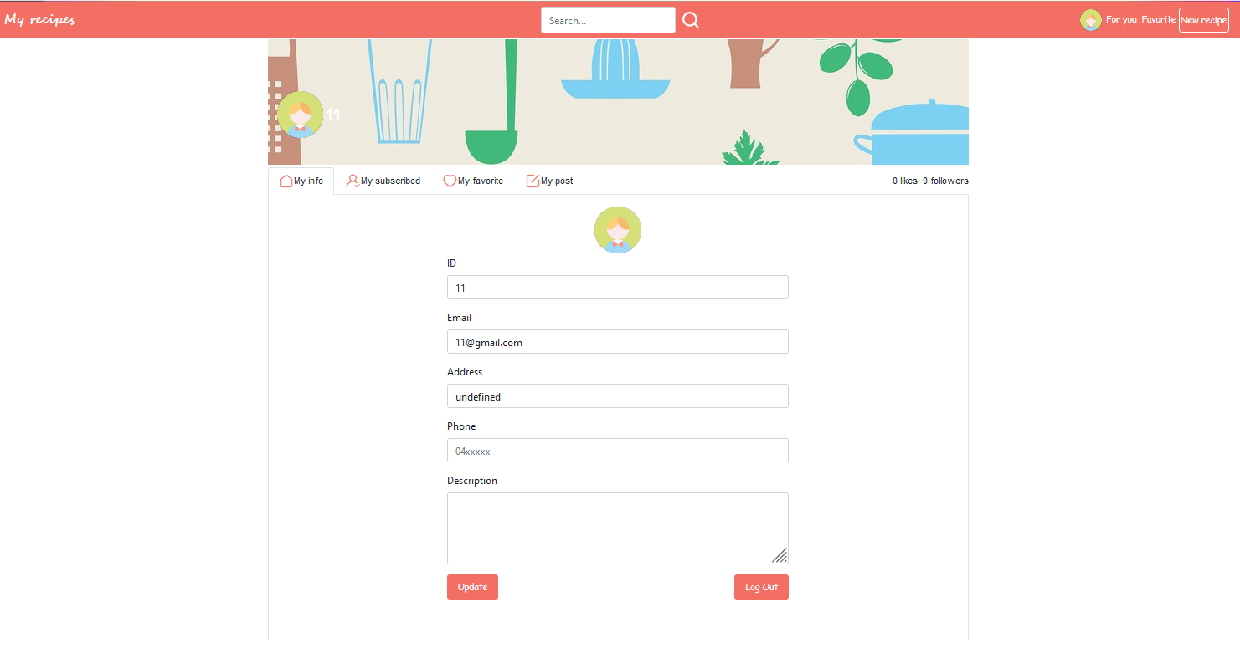

Figure 5.2.3.1 Default Profile Page

#### 5.2.3.2 Update Profile

On the profile page, users can change their information except for the email address which is used to register the account. By clicking the profile picture in the center of the page, our user can choose and upload a new picture for his/her account (Figure 5.2.3.2).

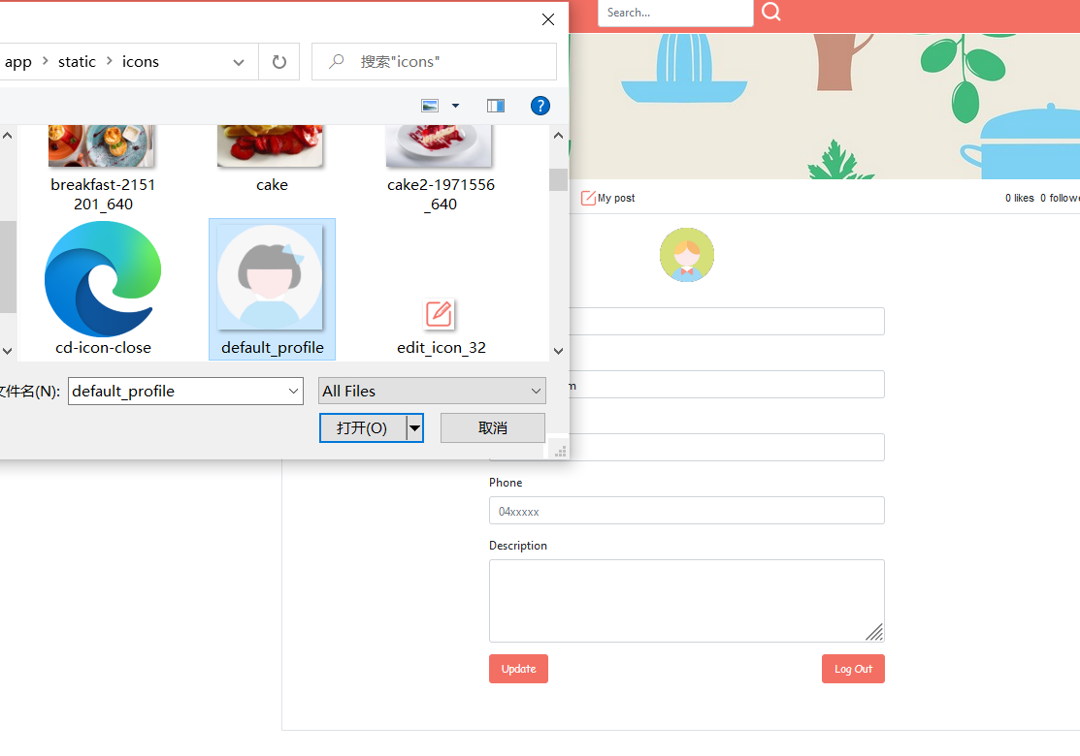

Figure 5.2.3.2 Change the Profile Picture

After updating the information on profile page, user can click the “update” button at the bottom of the page (Figure 5.2.3.3). Then all the new information will be stored. Then all the personal profile information will update on the website.

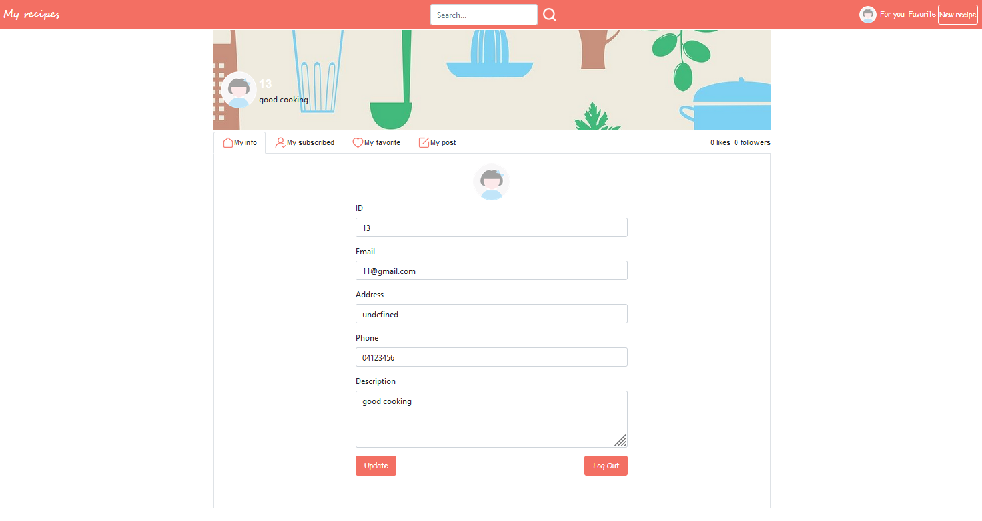

Figure 5.2.3.3 Change the Profile Picture

#### 5.2.3.3 Check total likes

At the right-top corner of the white container. Our user can easily find the number of the likes he/she gain. In this section (Figure 5.2.3.4), the follower number is showed on the bar as well.

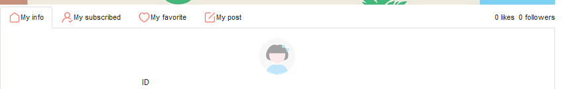

Figure 5.2.3.4 Total Likes Number

### 5.2.4 Recipe

#### 5.2.4.1 Create recipe

After user login, he/she can create new recipe by clicking “New recipe” button in top bar of any pages (show in Figure 5.2.4.1.1). A recipe consists of title, recipe type, cooking method, description, picture, ingredients, and steps. There are several ingredients and steps probably. Thus, a plus button is designed for adding every single ingredient and step (shows in Figure 5.2.4.2). Users are able to check all the recipes posted by themselves in “my post” tab under profile page (shows in Figure 5.2.4.3).



Figure 5.2.4.1 Top Bar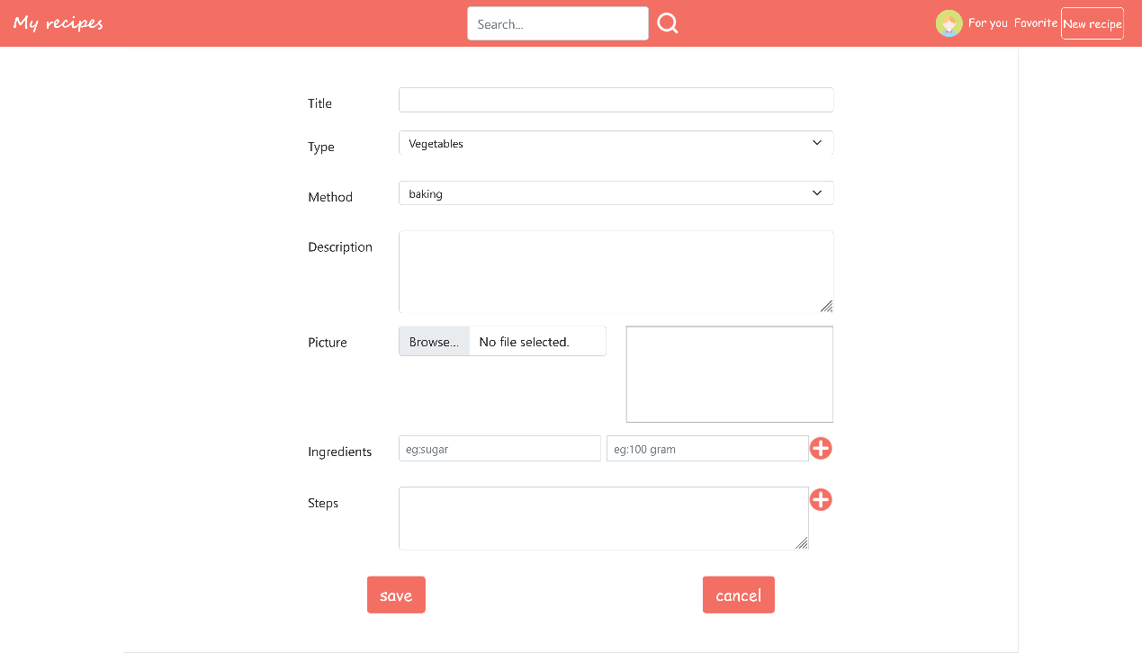

Figure 5.2.4.2 Create Recipe

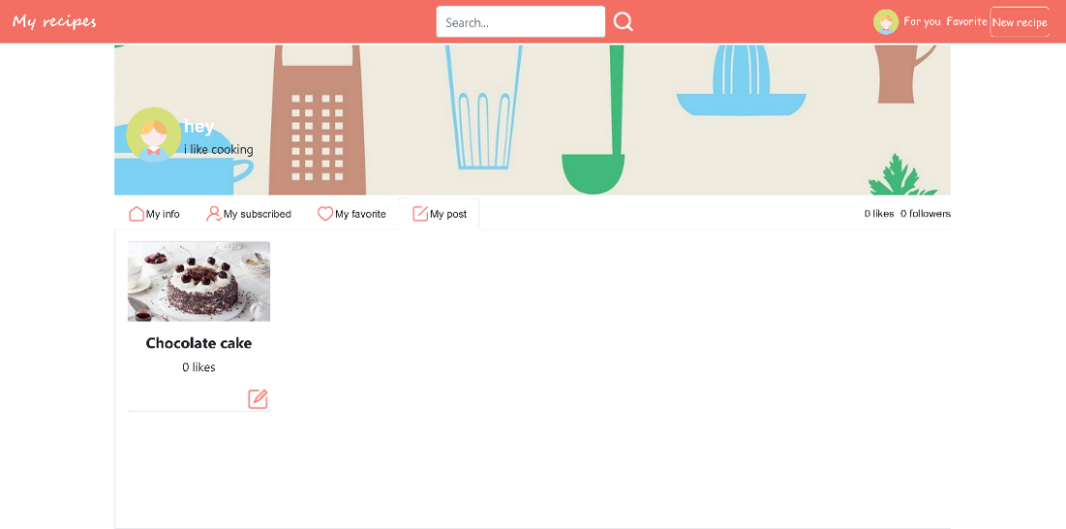

Figure 5.2.4.3 User Posts

#### 5.2.4.2 Edit and delete recipe

When user would like to edit posted recipes, he/she can click edit button (shows in Figure 5.2.4.3) in the corner of recipe then edit it (shows in Figure 5.2.4.4). If these recipes are old fashioned, user can delete recipe in the same page.

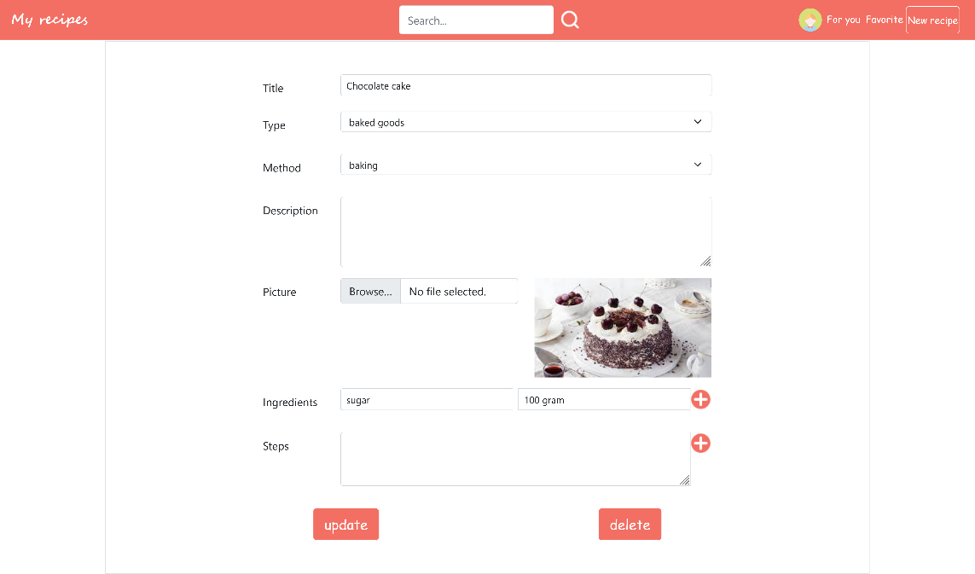

Figure 5.2.4.4 Edit Recipe

### 5.2.5 Search

A search bar is designed at the center of the navigation bar, users can search what they want anytime on any page of our website (Figure 5.2.5.1). They can enter keywords on the search bar and press the search button. Then they will be directed to the search page, with a list of recipes as a keyword-search result (Figure 5.2.5.2).

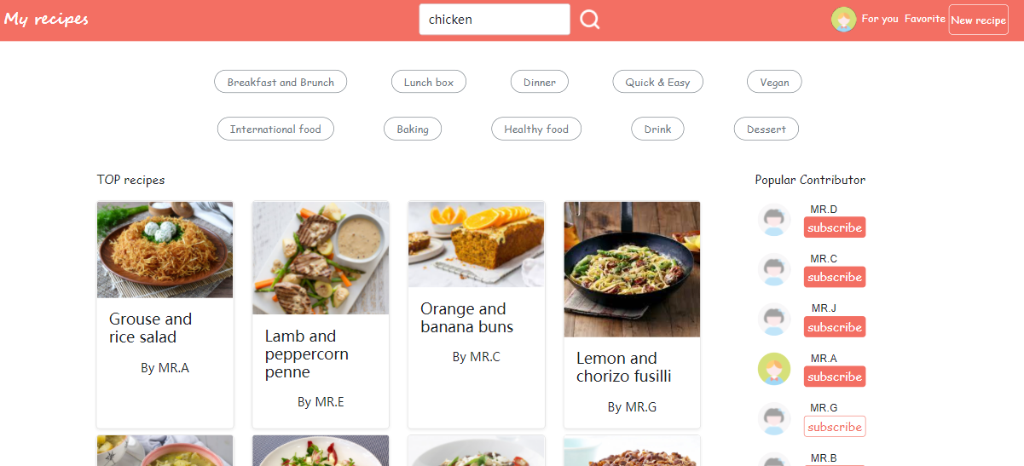

Figure 5.2.5.1 Main Index Page

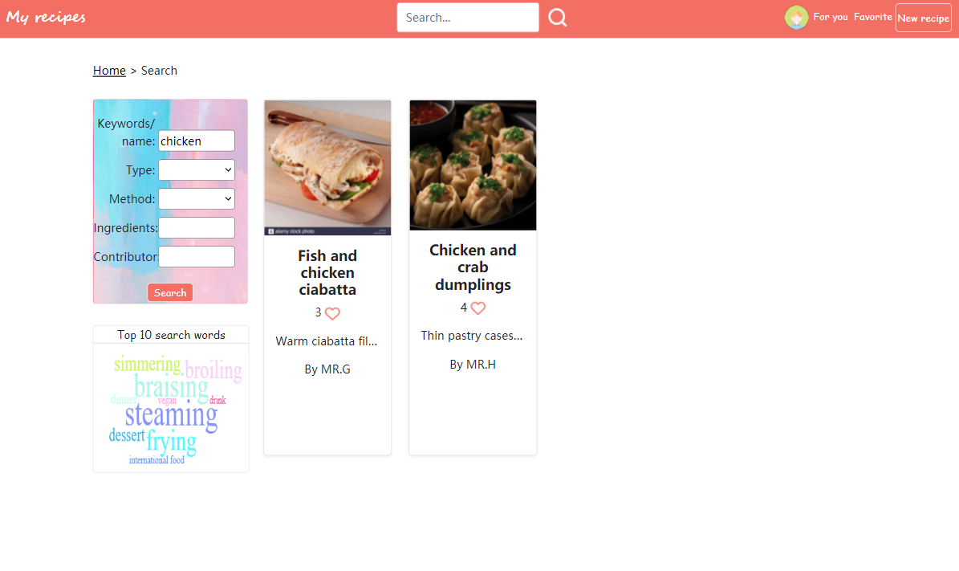

Figure 5.2.5.2 Search Result Page

s

#### 5.2.5.1 Filters

Some recipe type filters are designed as quick accesses on the index page of our website. Though pressing these filters, users can easily search different types of recipes (Figure 5.2.5.3 and Figure 5.2.5.4).

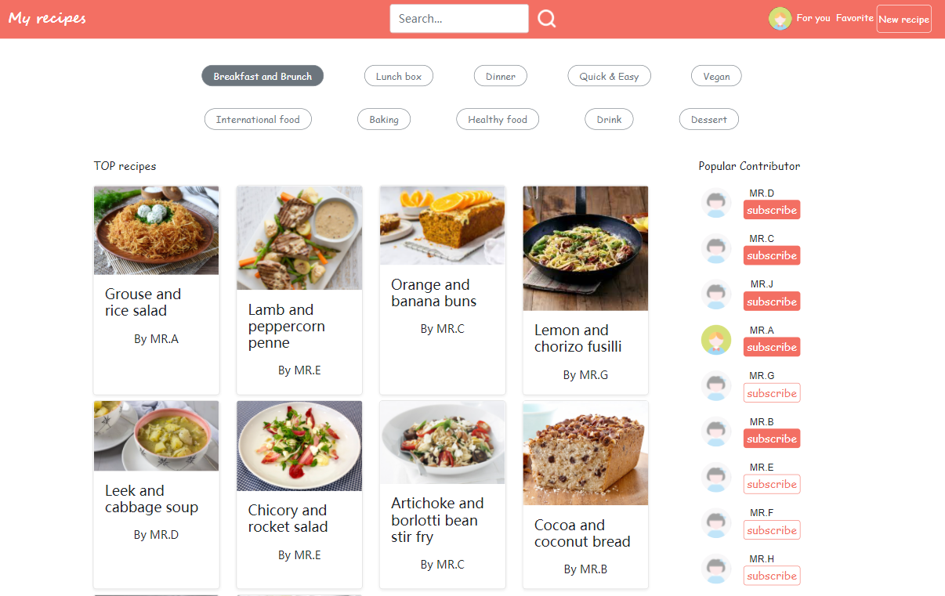

Figure 5.2.5.3 Filter Method on Main Page

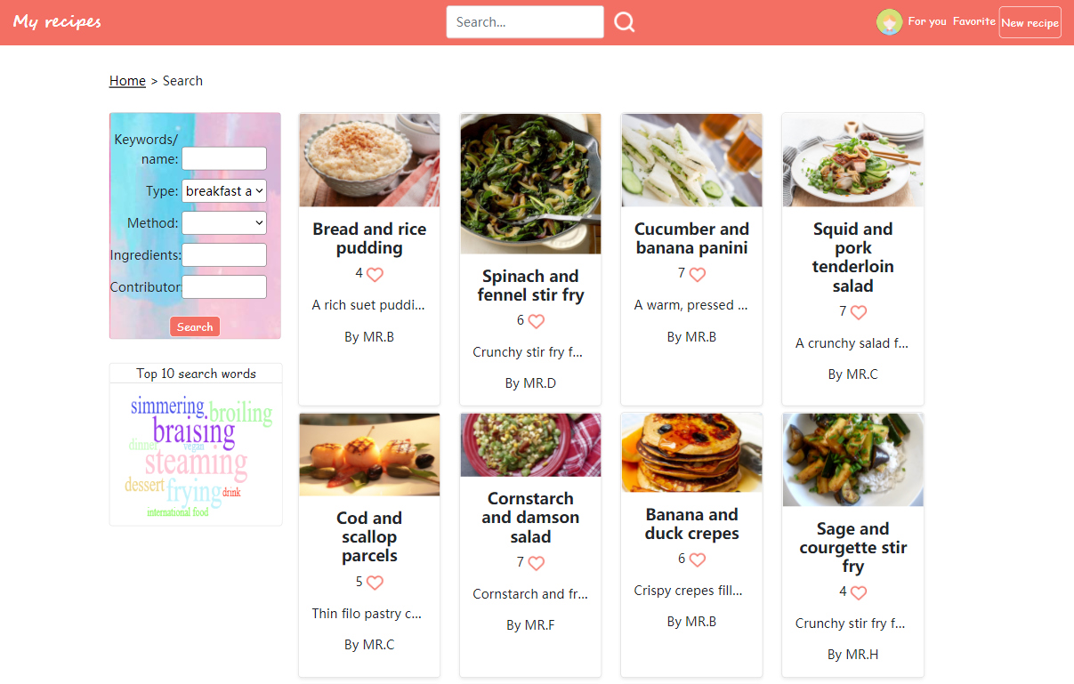

Figure 5.2.5.4 Filter Method on Search Page

#### 5.2.5.2 Search by different conditions

Users can find recipes they are interested in based on any combination of the following: ingredients, method, meal-type(s), and recipe name.

On the left-hand side of the page is a multi-condition search box, users can choose different search conditions. For example, if a user wants to search recipes based on recipe name, he/she can enter the name of the recipe in the keyword box (Figure 5.2.5.5). If a user wants to search dinner recipes with milk ingredient, he/she can select ‘dinner’ option in the “Type” box, and then type in ‘milk’ in the ingredient box (Figure 5.2.5.6).

On the right-hand side is a resulting list of recipe summaries. After clicking the title of the recipe, the user can be navigated to the detail page of that specific recipe.

Below multi-condition search box is a cloud graph of top 10 search words, from which users can know the trend of recipes.

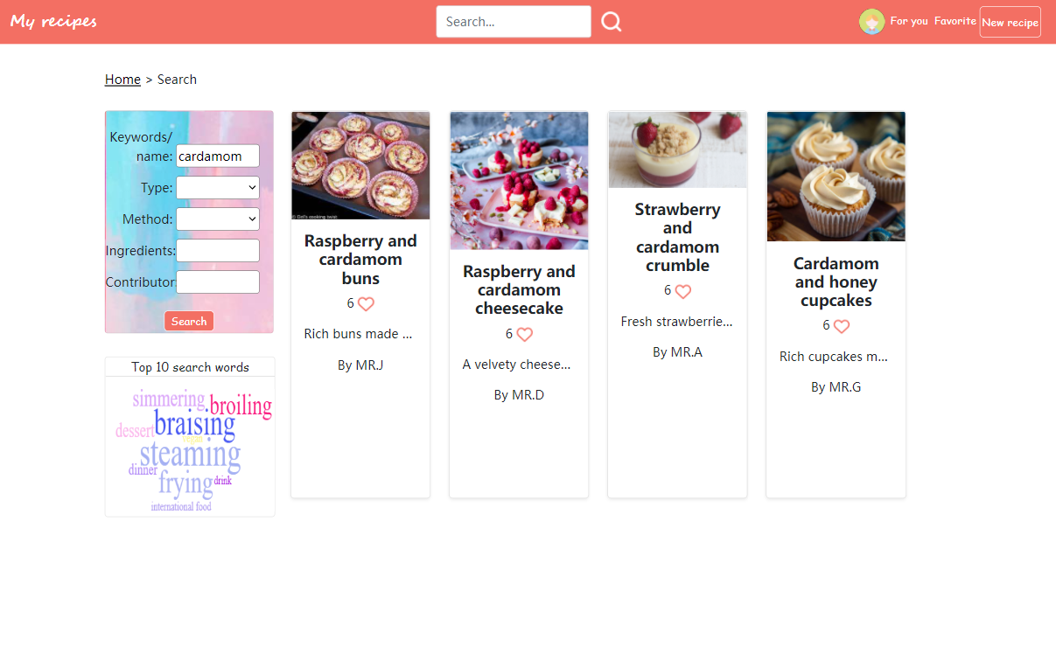

Figure 5.2.5.5 Keyword Box on the Left Side

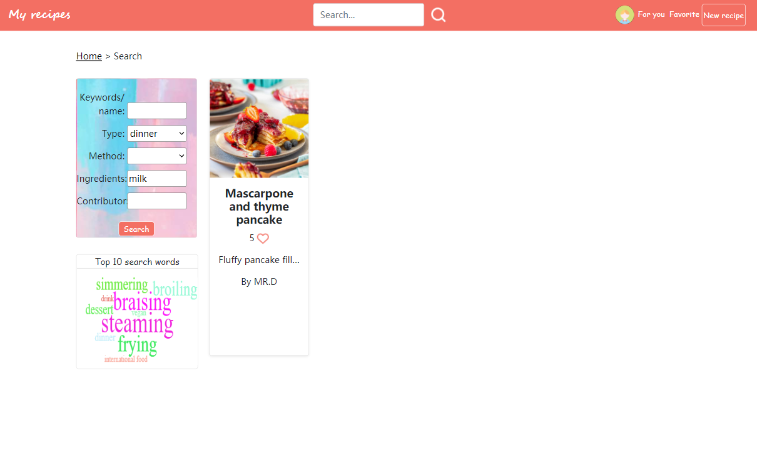

Figure 5.2.5.6 “Type” Search Result

### 5.2.6 Interaction

#### 5.2.6.1 Likes

For contributor, the amount of likes directly shows how popular his/her recipe is (Figure 5.2.6.1.1) and how popular he/she is (figure 5.2.6.1). For explorer, he/she can like what he/she interests in and can review the recipe liked by him/her (figure 5.2.6.2). Explorers can like or cancel like by clicking heart icon in any page of showing this icon.

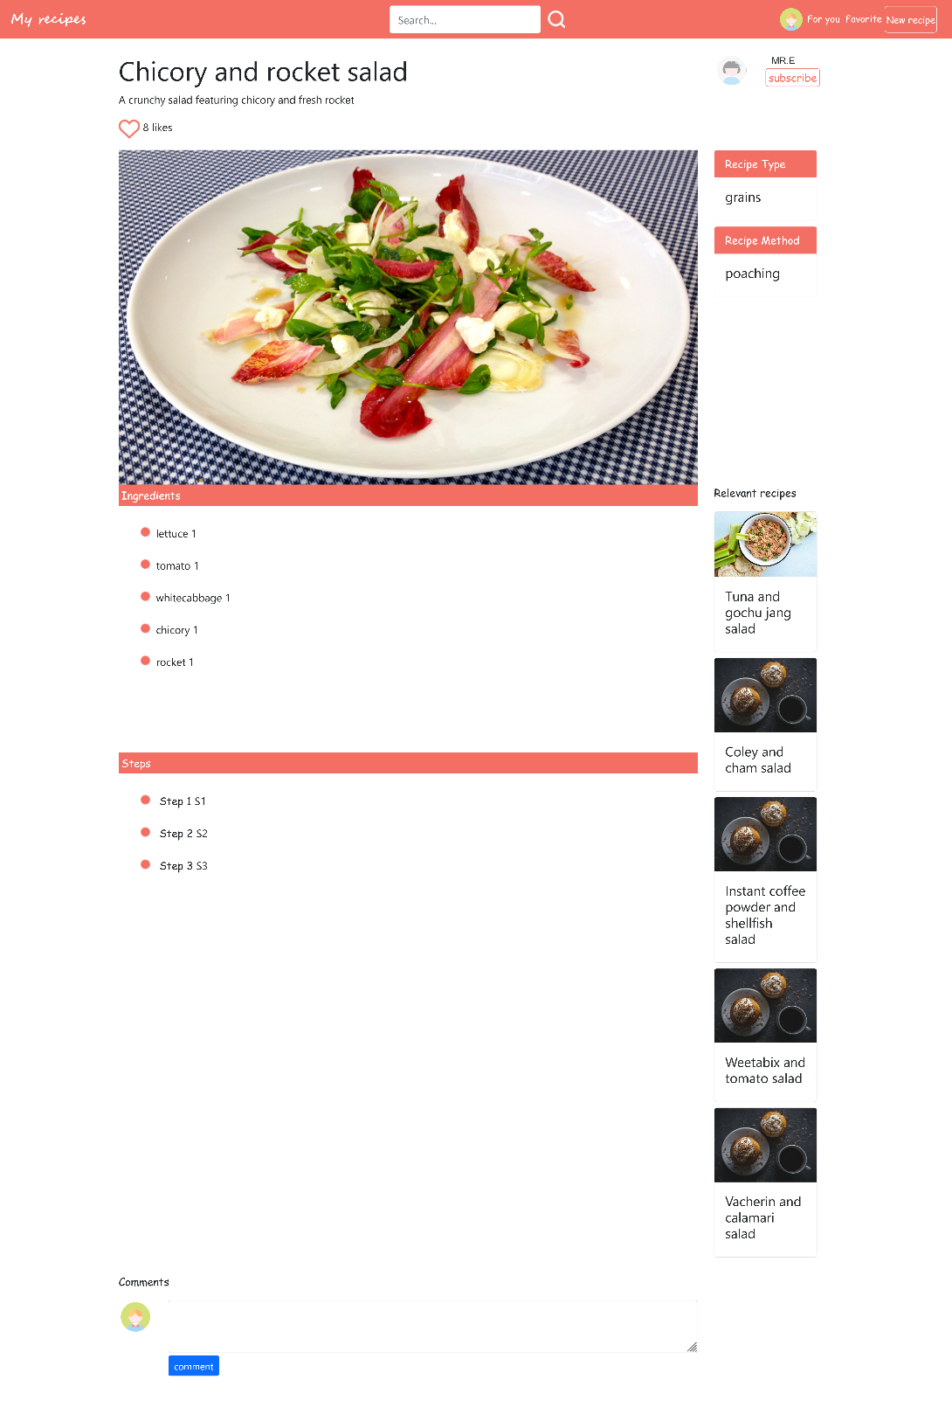

Figure 5.2.6.1 Likes on the Detail Page

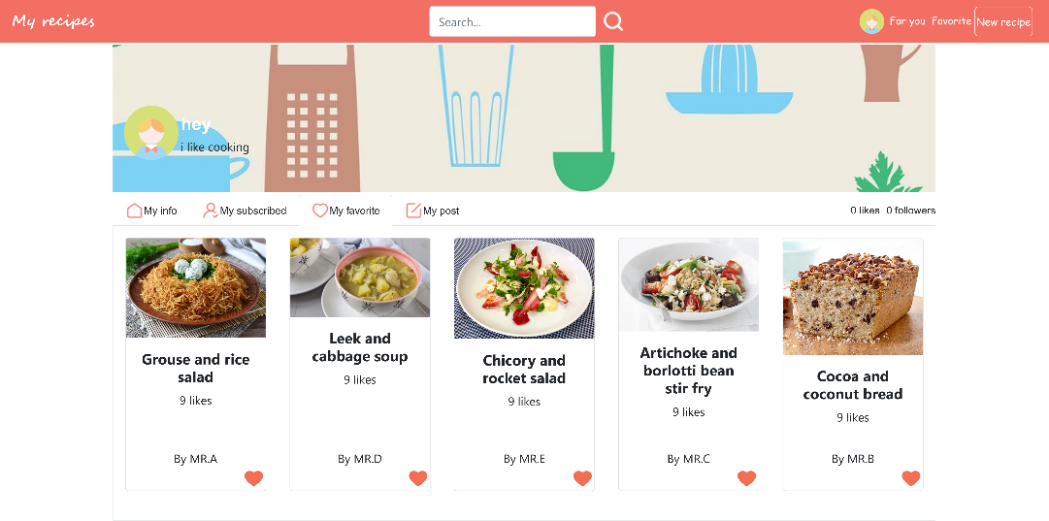

Figure 5.2.6.2 Explorer’s Likes In My Favorite

#### 5.2.6.2 Comments

In recipe detail page, there is a comment button at the bottom of page and only logged in user can comment recipes and can see other’s comments on this recipe (Figure 5.2.6.3).

Only logged in user can comment recipes and can see other’s comments on it.

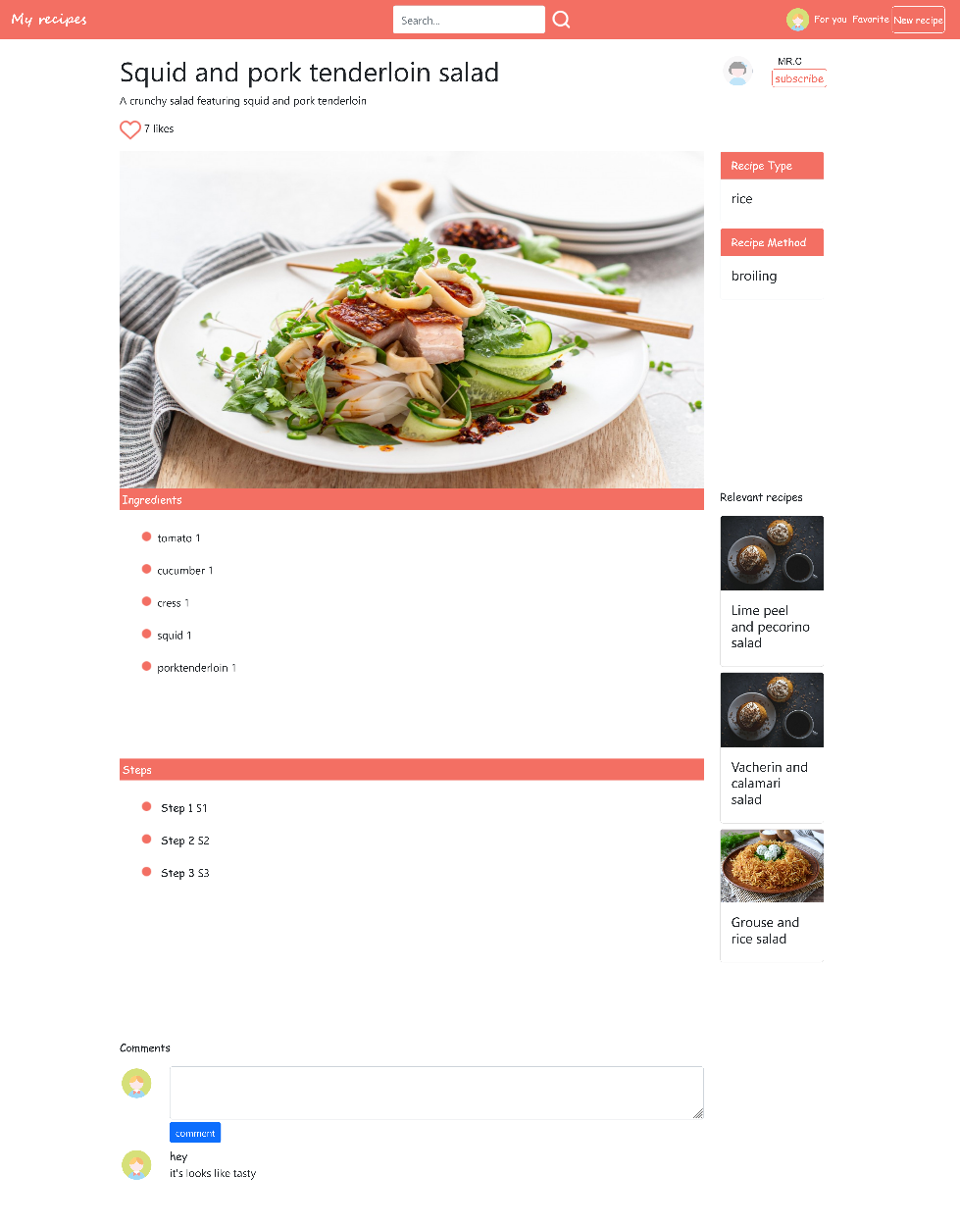

Figure 5.2.6.3 Comment, Like and Subscribe

#### 5.2.6.3 Subscribe

As an explorer, he/she may interest in some contributors and want to see recipe that posted by them. Explorer can subscribe contributors (Figure 5.2.6.3 above) and can explore recipes shared by them in news page (shows in section 2.7.2).

### 5.2.7 Personalization

#### 5.2.7.1 My Favorite

My favorite section is a page shows the user those recipes he/she liked before. Then entrance button of my favorite page is on the right top of navigation bar (Figure 5.2.7.1). Click the “Favorite” then you can jump to my favorite page.



Figure 5.2.7.1 “Favorite” Button in Navigation Bar

User also can entry my favorite page by click “my favorite” button on the profile page (Figure 5.2.7.2).

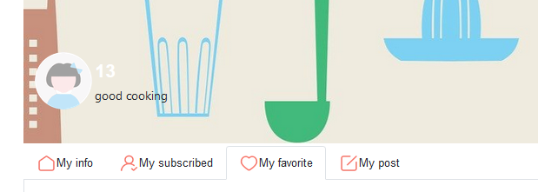

Figure 5.2.7.2 “My favorite” Button on Profile Page

On the favorite page (Figure 5.2.7.3), our user can check the recipes that he/she liked. User can give/cancel the like by clicking the heart button of every recipe. Besides, we also provide a convenient method if user click the name of the recipe, he/she will automatically jump to the detail page of the specific one.

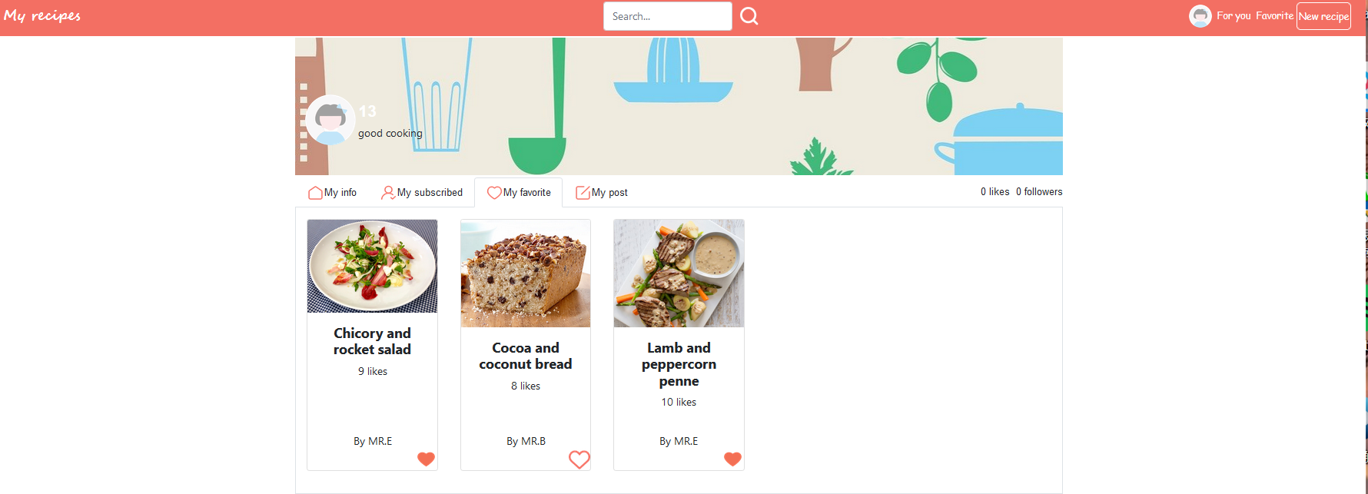

Figure 5.2.7.3 “My favorite” Page

#### 5.2.7.2 My Subscribe

My subscribe section (Figure 5.2.7.4) is parallel with the section my favorite. However, we do not provide another button to jump-in on our main navigation bar. User can jump into my subscribe page by clicking the “My subscribed” button on the white navigation bar of the profile page.

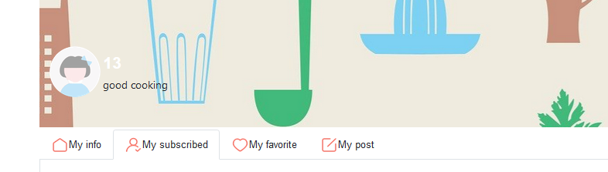

Figure 5.2.7.4 “My Subscribe” Button

In “My subscribe” section (Figure 5.2.7.5), our user can easily check the contributors he/she followed. By clicking the “subscribe” button under every other contributor’s name, our user can unsubscribe or resubscribe people easily.

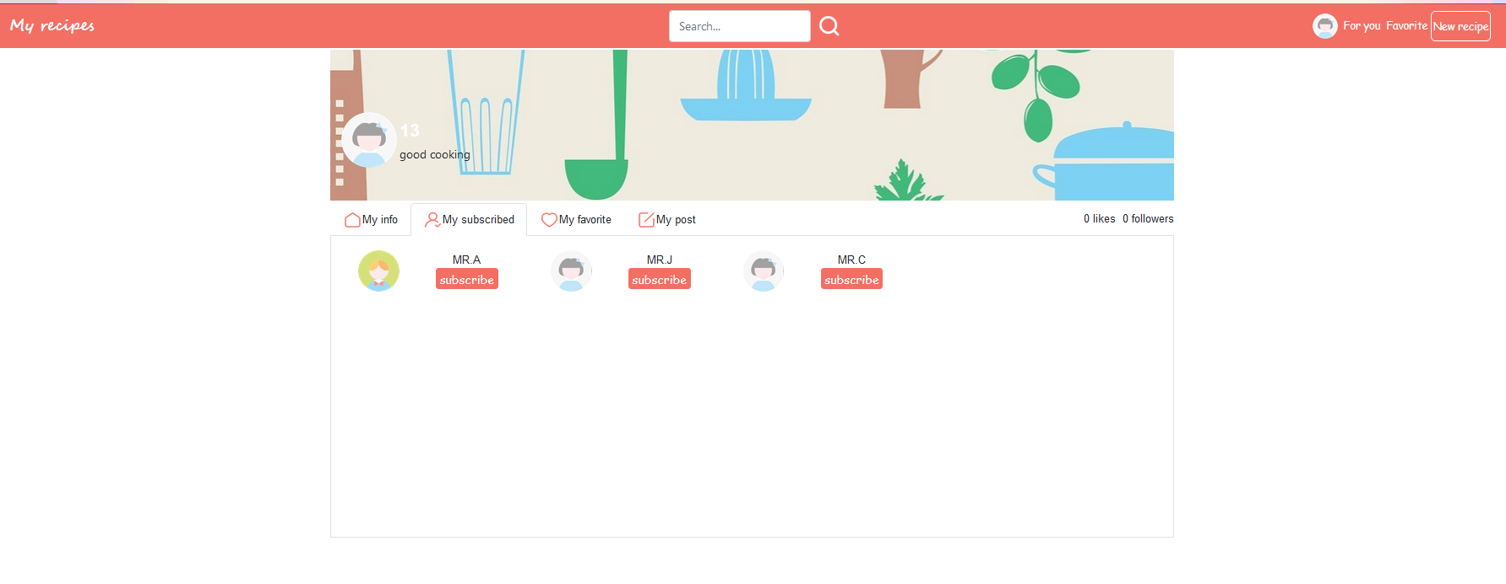

Figure 5.2.7.5 “My subscribe” Page

#### 5.2.7.3 My Post

In my post section (Figure 5.2.7.6), we provide a website for user to check their posted recipes. Click the button “my post” on the sub-navigation bar of the profile page. User can jump to my post page directly. We also provide the function that user can click the “edit” button under every recipe card and jump to the recipe-editing page of the specific recipe. As if the user requires to check the recipe detail, clicking the recipe name of each card can help users jump to recipe detail page.

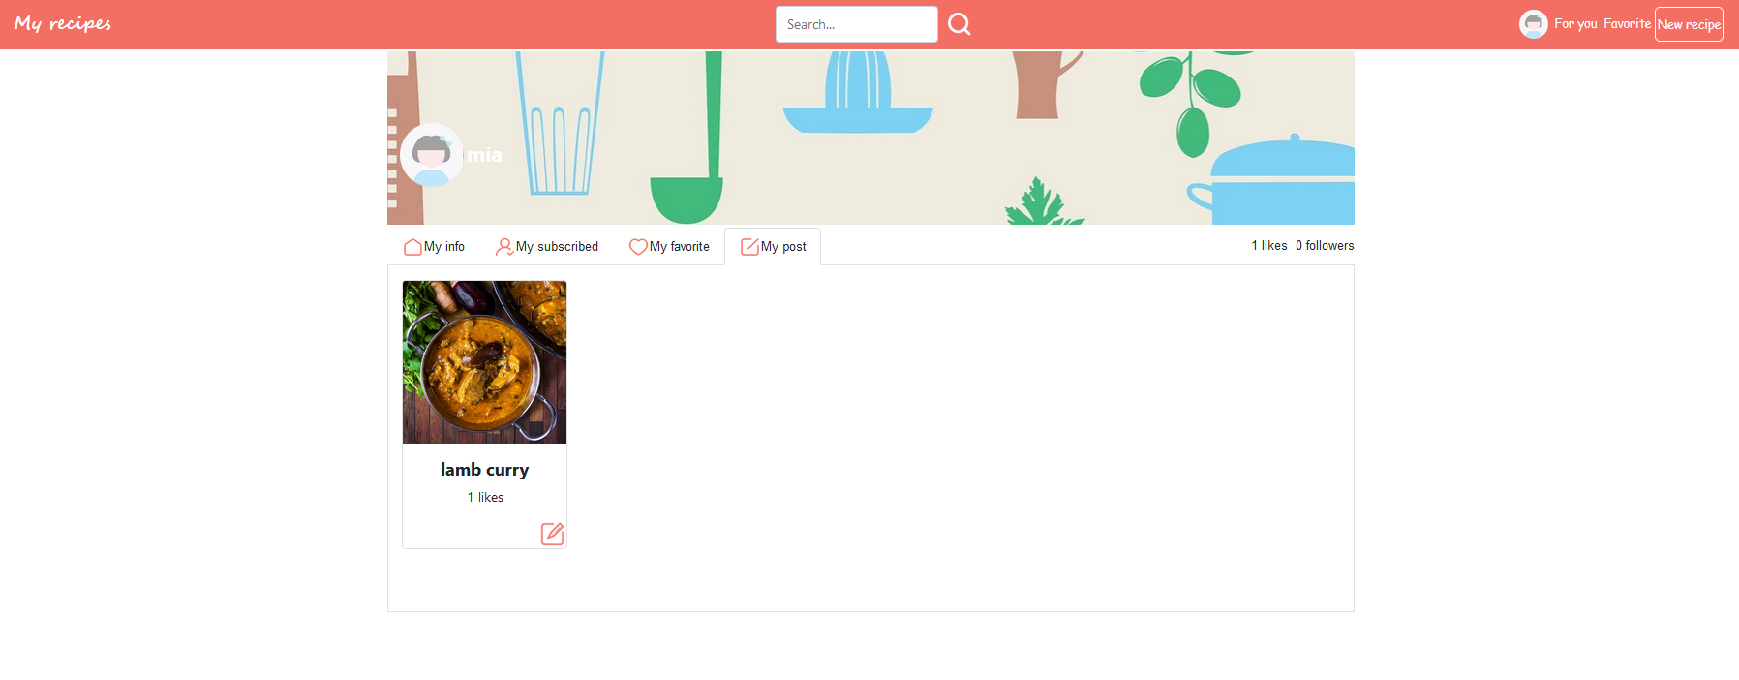

Figure 5.2.7.6 “My post” Page

#### 5.2.7.4 For you

Our “For you” section (Figure 5.2.7.7) provide a news page which based on the updating contents from contributors that the user subscribe to. User can click the “For you” button on the top right of the main navigation bar and easily move to the news page. The container at the right side of the page shows the basic information of the user. There is personalized news listed based on how recently recipes have been created or updated, and how many likes the explorer has for each recipe contributor's profile. Our user can check the create time and like number for a specific recipe easily. If he/she find some interesting recipe. They can click the name of it and jump to the detail page. Similarly, click the heart button of a recipe can give the a like to it.

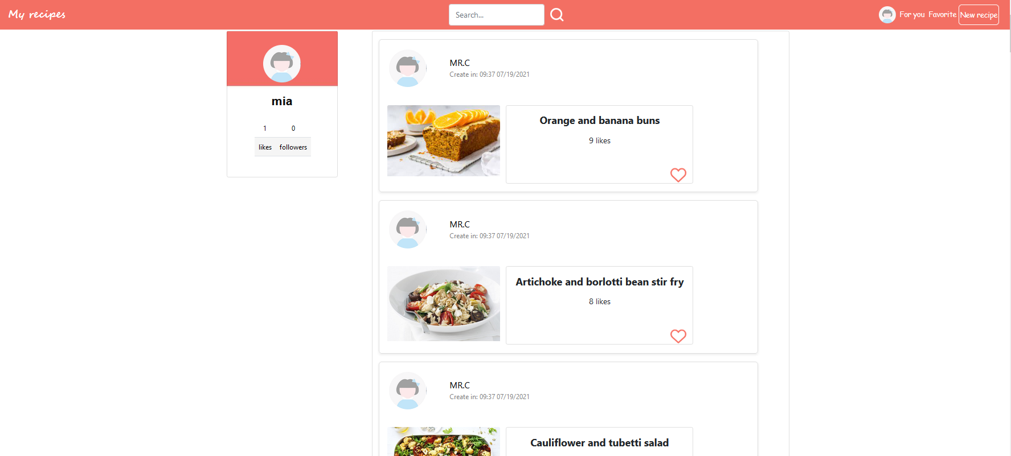

Figure 5.2.7.7 “For you” Page

# 6. Reference

Flask. (2021). User’s Guide. Retrieved from <https://flask.palletsprojects.com/en/2.0.x/>

SQLAlchemy. (2021). The Python SQL Toolkit and Object Relational Mapper. Retrieved from <https://www.sqlalchemy.org/>

Bootstrap <https://getbootstrap.com>

Wordcloud2 <http://timdream.org/wordcloud2.js/>

Codyhouse.co [CodyHouse | Web Design Nuggets](https://codyhouse.co/)